Certificate of Analysis

General properties:
Name：PLGA15000-PEG5000-MAL, PLGA:75/25
Molecular Weight：20150 Dalton
Cat.#： R-P-105015
Lot.#： RP201604011
Manufacture Date： 2016.04.11
Date of Analysis： 2016.04.11
Recommended Retest date： 2017.04.11
Stability： 12 months
Storage： -20°C in the dark
Structure

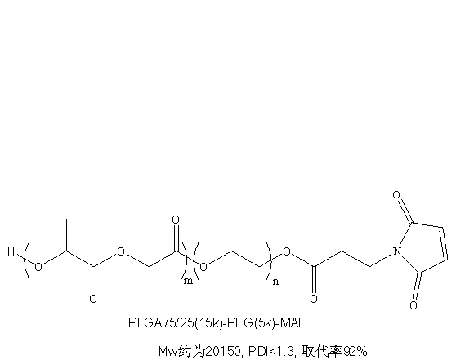

Items | Specification | Results
Appearance | White/ Off-white solid | White solid
¹H NMR | Identical to the Structure | Identical to the Structure
Foreign Material | None | None
Substitution | ＞90% | 92%
PDI |  | <1.3
Report Date: 2016.04.11

This product is for research use only, Not for human or animal use

